Hardware & Software Requirements
- Windows 10 OS Laptop/Desktop
- Device with NVIDIA Graphic Card (with CUDA ability)
- Visual Studio Code (with Python extension installed in VS Code)
  - System version - https://code.visualstudio.com/download
- Microsoft C++ Build Tools
  - https://visualstudio.microsoft.com/visual-cpp-build-tools/
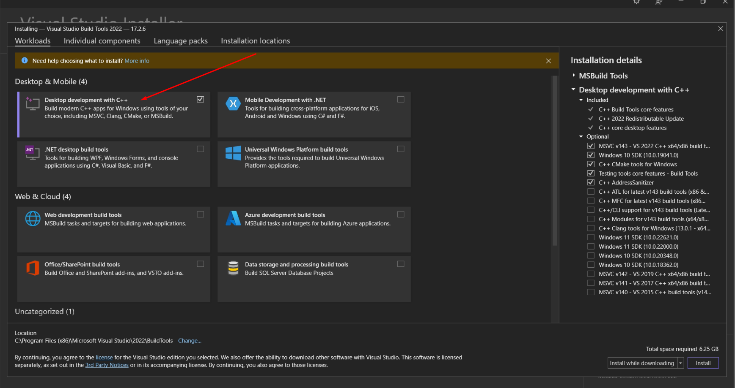
- Python interpreter
  - https://www.python.org/downloads/release/python-391/
- Anaconda Environment
  - Windows - https://docs.anaconda.com/anaconda/install/windows/
- Microsoft Visual C++ 2015 Redistributable Update 3
  - https://visualstudio.microsoft.com/vs/older-downloads/#microsoft-visual-c-2015-redistributable-update-3
- Install PIP and add to windows environment variables
  - https://phoenixnap.com/kb/install-pip-windows

Installation Setup
- Ensure your device had fulfilled the requirements above.
- Extract the "FYP-eVision" folder in the source code zip to the desktop location.
- Initiate Visual Studio Code and click File > Open Folder and selected the "FYP-eVision" folder that you had extracted.
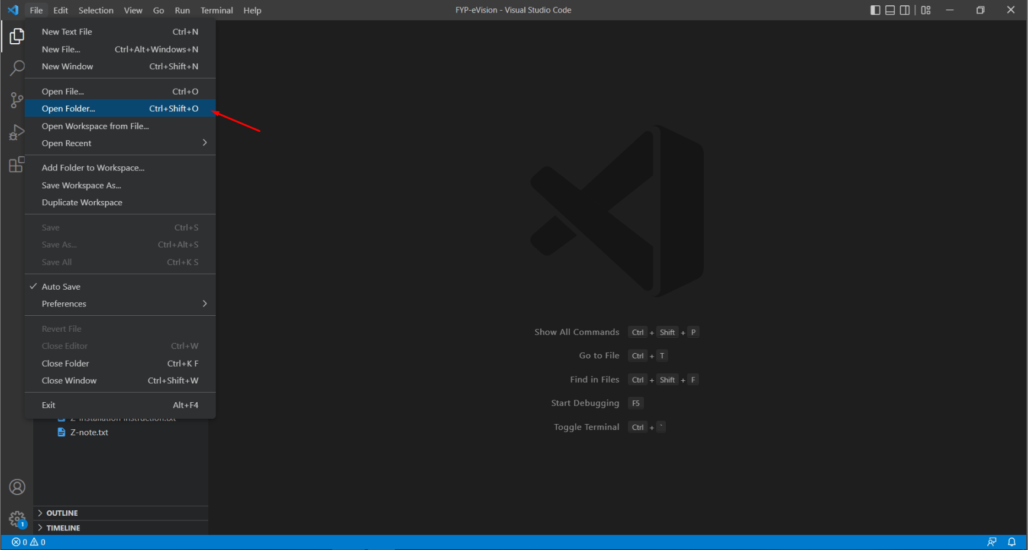
- Open new vs code terminal.
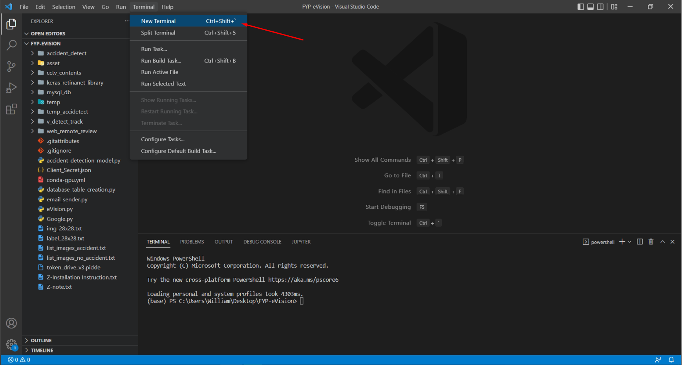
- In the terminate type in 'conda env create -f conda-gpu.yml' without the quotes to create a new interpreter environment for initiate the system.
(If the conda command is not recognized in VS Code terminal, go to Anaconda Prompt and type ‘conda init powershell’, then restart a new terminal in your VS Code and try again with command above to create the environment)
(Recreate the environment if encountered errors, please uninstall and re-install the environment)
('conda env remove -n conda-cuda-gpu' -> to uninstall the environment, then 'conda env create -f conda-gpu.yml' again to install the environment)
- After successful creation of environment, activate the environment created by using ‘conda activate conda-cuda-gpu’
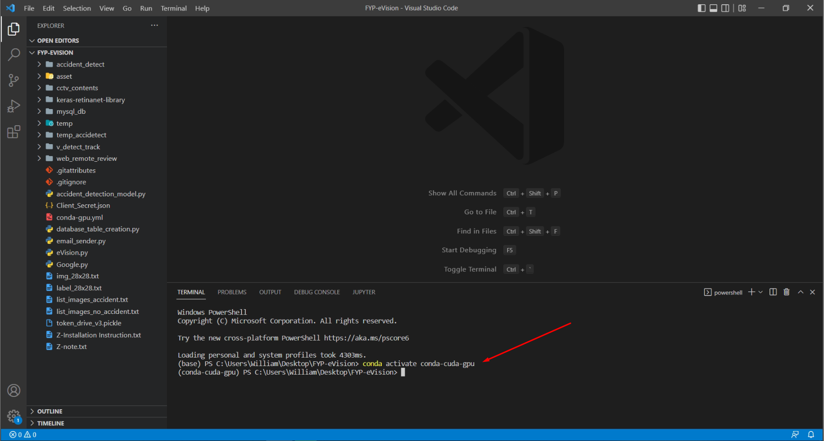
- In the vscode terminal, cd to keras-retinanet-library folder
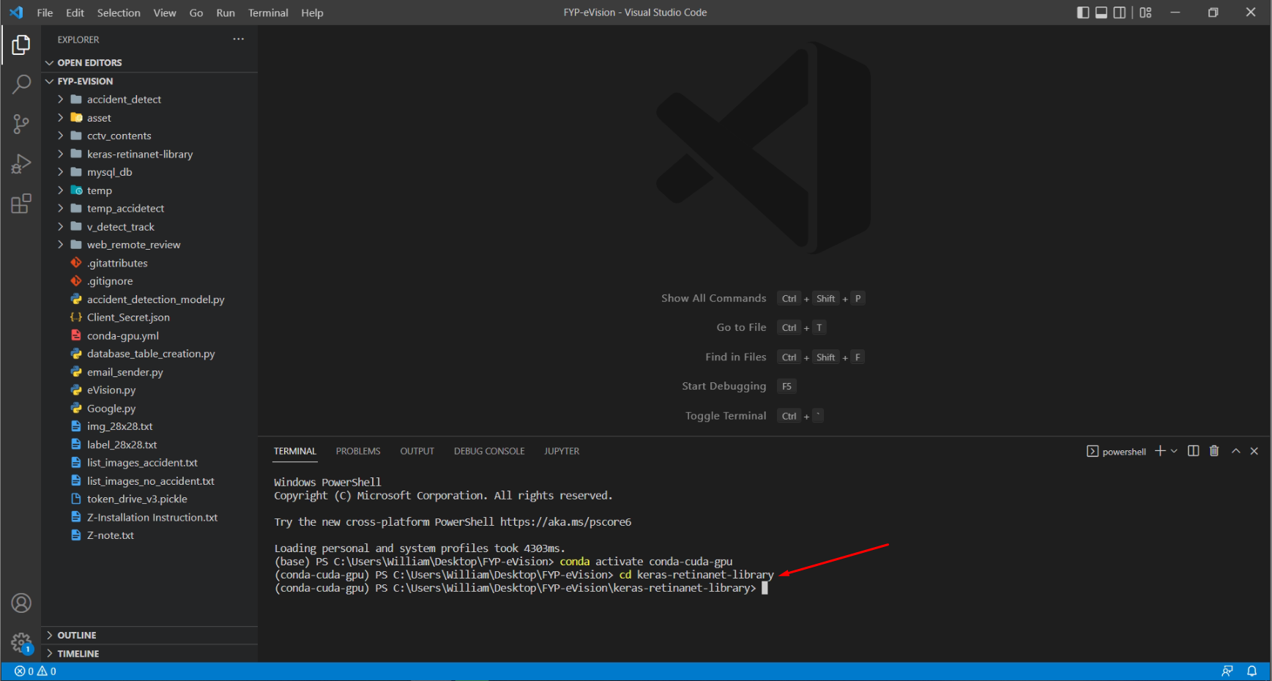
- Install the keras-retinanet-lirbrary using 'pip install . --user' and 'python setup.py build_ext --inplace'
- Navigate to eVision.py file and change the interpreter to the conda-cuda-gpu that had been created.
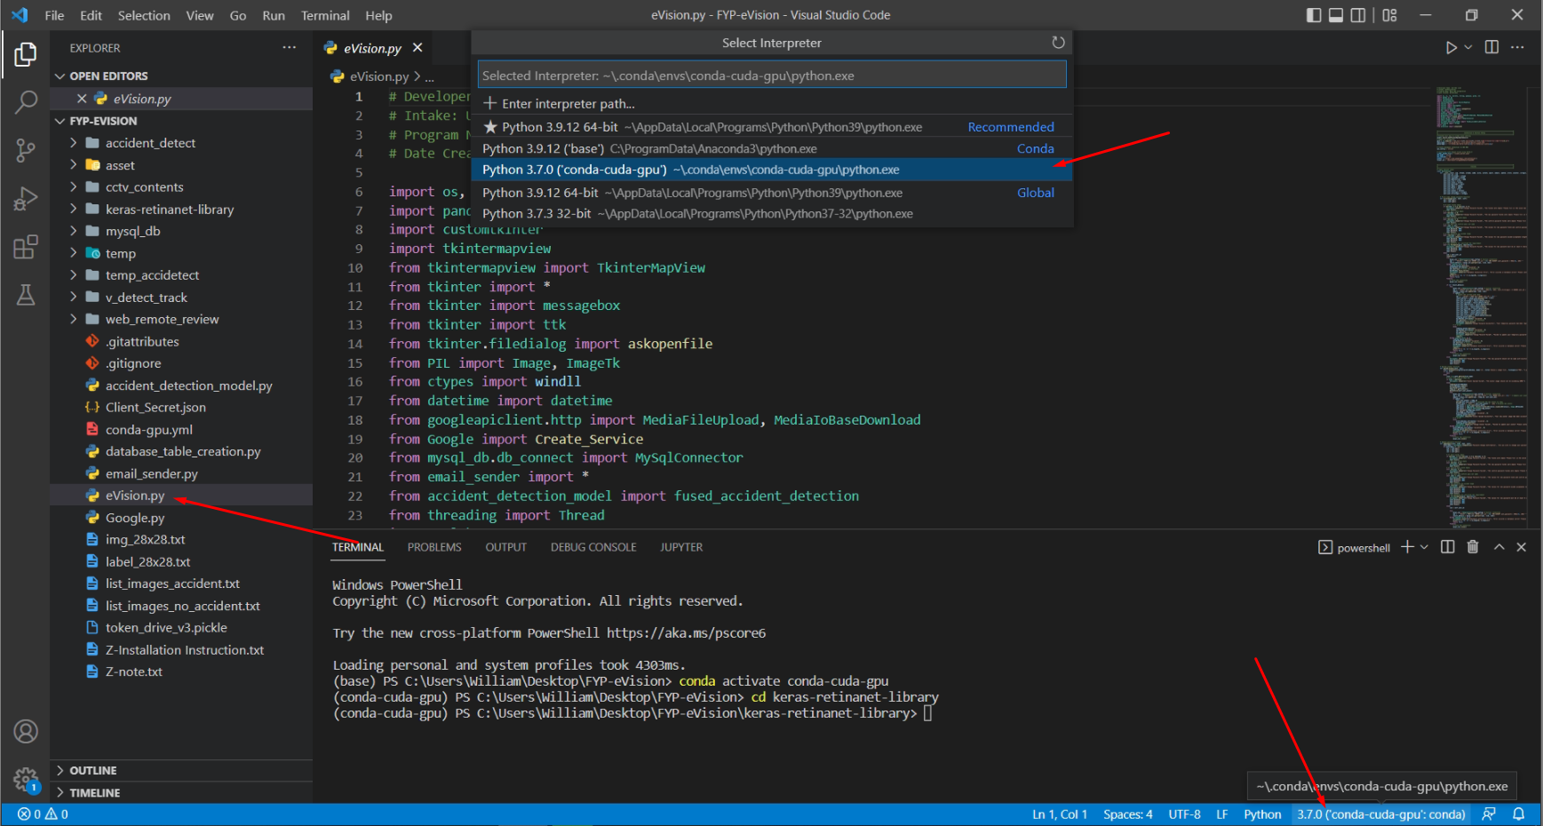
- Initiate the eVision.py file.
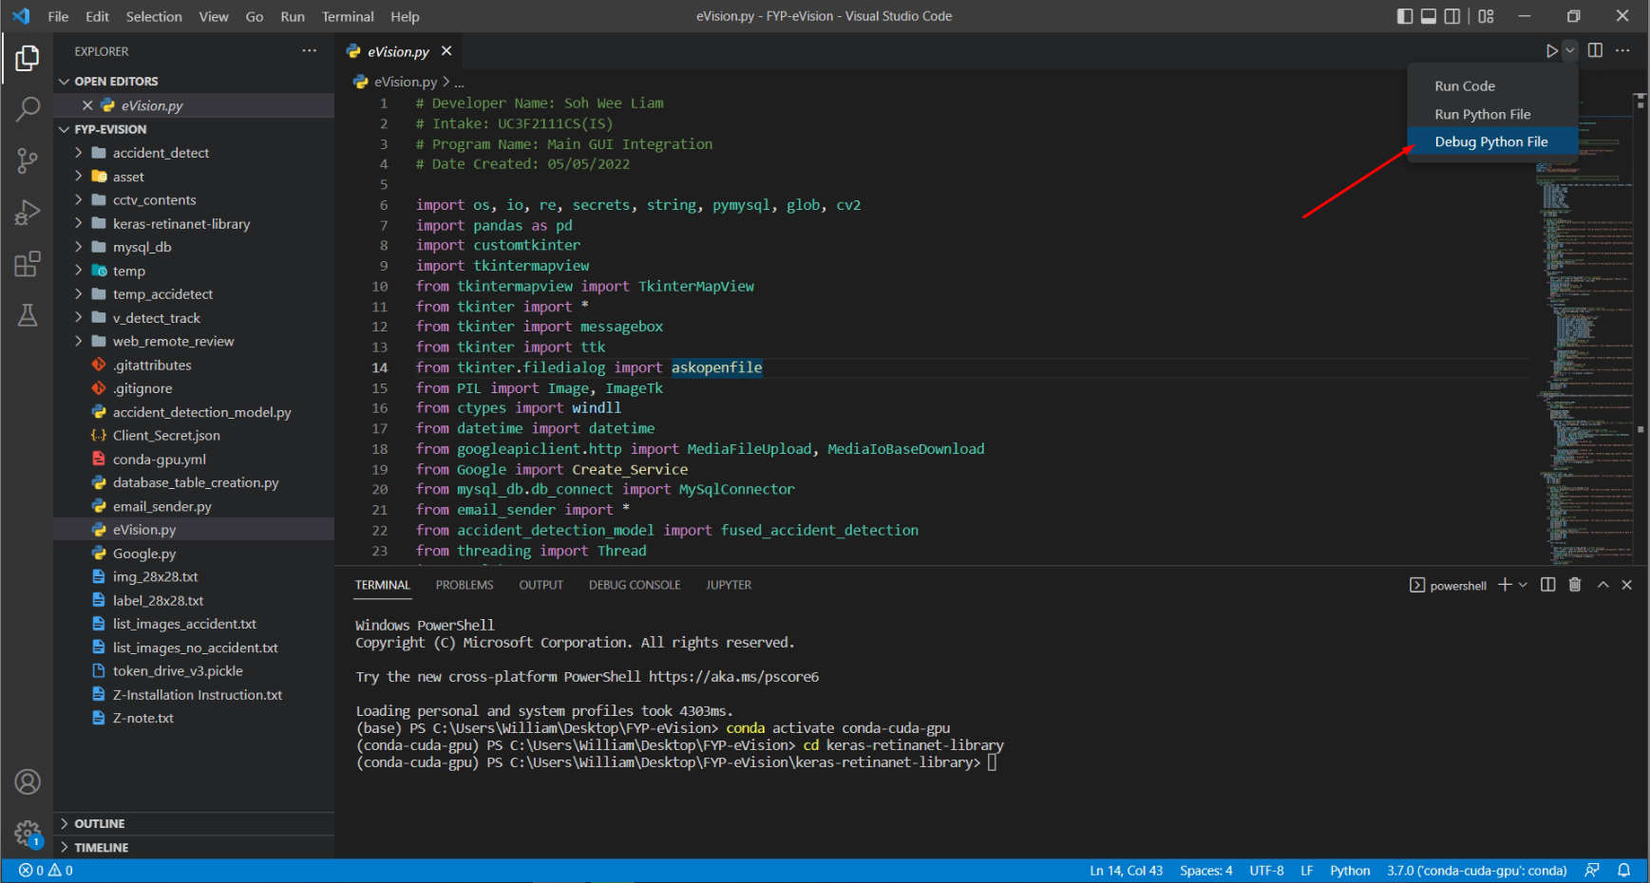
- The e-Vision login page will be displayed and login with a valid credential account (see detail in end of page for credentials access)
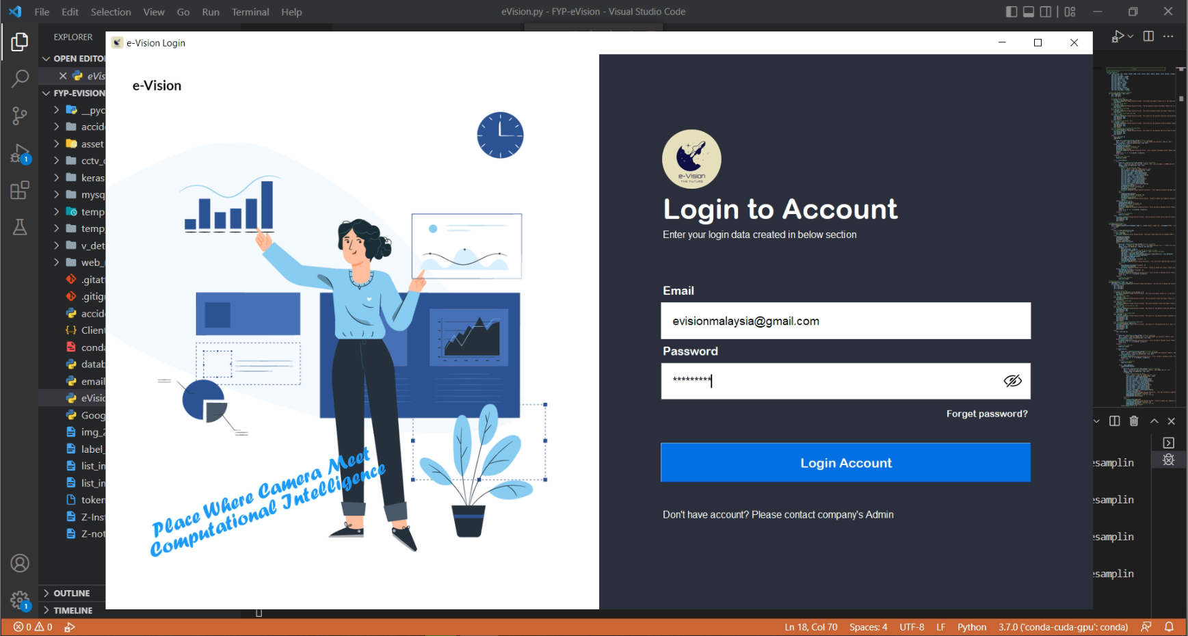

- Web browser will be popped up to ask to log in to any google email credential. (Will only need to do for first time access to the system)
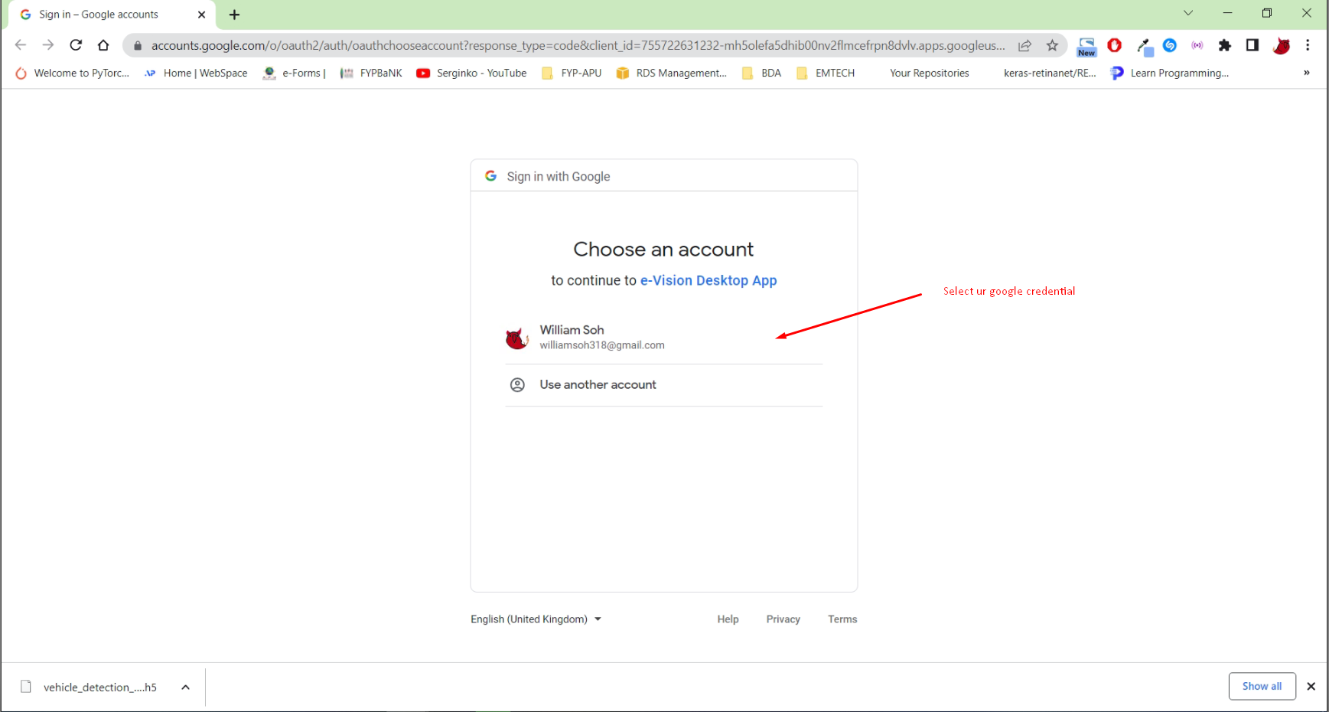
- After entered the valid credential, click on 'Advanced' and click on 'Go to e-Vision Desktop App'.
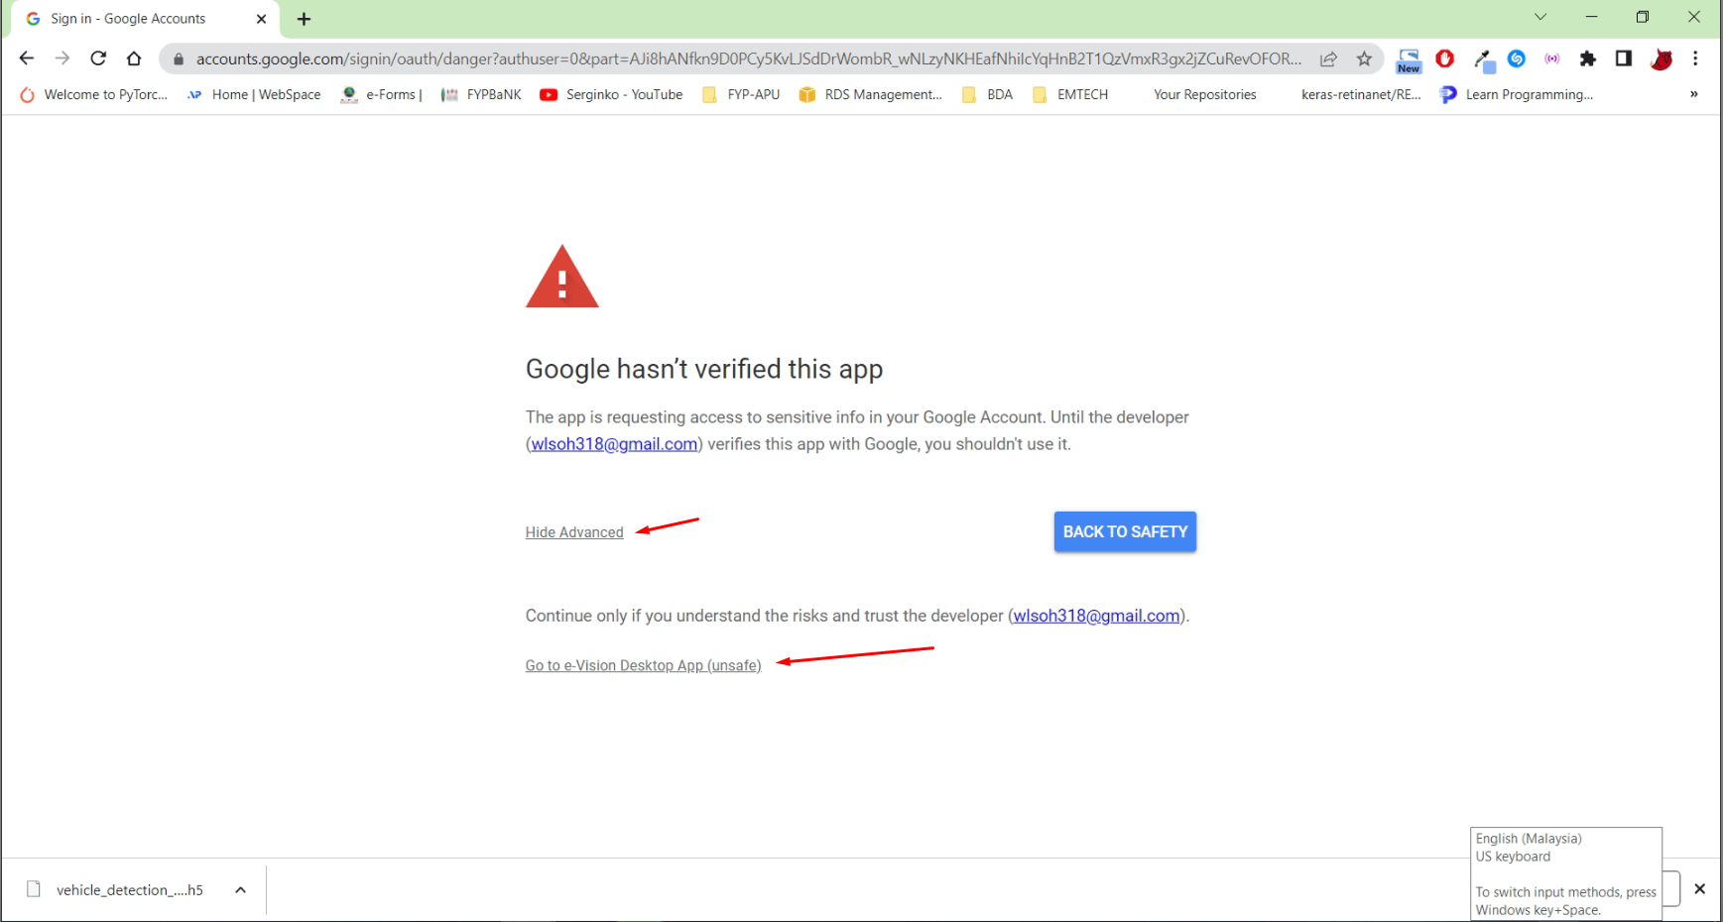
- Then, allow access by click on 'Continue' button.
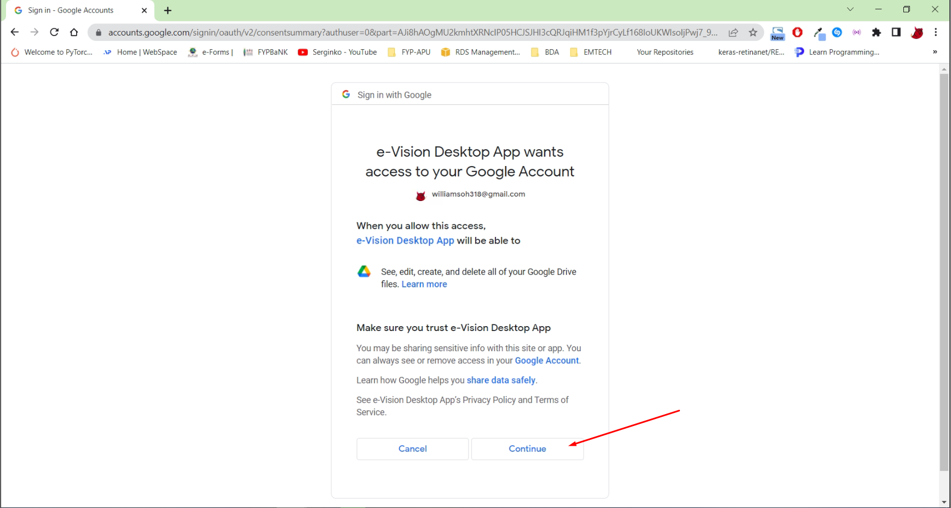
- Once completed, the e-Vision application will be able to logon successfully. (Can continue to access with other features of e-Vision)

Note: any extra initiation package errors, can use pip install to resolve.

e-Vision Master Admin Credential:
- Email: evisionmalaysia@gmail.com
- Password: admin1010

